**Usman Institute of Technology**

**Department of Computer Science**

**Course Code: SE312**

**Course Title: Software Construction and Development**

**SPRING 2024**

**Lab 01**

**Objective: To provide hand-on experience in requirement gathering and elicitation.**

**Student Information**

|  |  |
| --- | --- |
| Student Name |  |
| Student ID |  |
| Date |  |

**Assessment**

|  |  |
| --- | --- |
| Marks Obtained |  |
| Remarks |  |
| Signature |  |

**LAB #01**

The objective of this lab is to provide participants with hands-on experience in requirements gathering, a critical phase in the software development lifecycle. Through practical exercises and discussions, participants will learn essential techniques and best practices for eliciting, documenting, and prioritizing requirements effectively.

Before starting a project, it is crucial to know;

* What is the purpose of your project?
* What is required?

These are some of the first questions you must ask, and they’re collected in a requirement gathering or requirements elicitation. It leads to the design and development of a successful project.

**Definition of Requirements Gathering:**

* Requirements gathering is the process of collecting, analyzing, and documenting information from stakeholders to understand their needs and expectations for a software system.
* It involves identifying, prioritizing, and documenting functional and non-functional requirements that will guide the development process.

**Importance of Requirements Gathering in Software Development:**

* Requirements gathering is crucial in software development as it lays the foundation for successful project outcomes.
* It ensures that the final product meets the needs of its users and stakeholders, leading to increased user satisfaction and adoption.
* Properly gathered requirements help in reducing project risks, minimizing costly rework, and improving project efficiency by providing clear guidance to development teams.

**Key Stakeholders Involved in the Process:**

The key stakeholders involved in requirements gathering include:

* **Customers/Users:** They provide insights into their needs, preferences, and expectations from the software.
* **Business Analysts**: They act as intermediaries between users and developers, facilitating communication and ensuring that requirements are clearly understood and documented.
* **Project Managers:** They oversee the requirements gathering process, ensuring alignment with project objectives, timelines, and budget.
* **Developers:** They implement the requirements and may provide valuable input during the gathering process regarding technical feasibility and constraints.
* **Quality Assurance/Testers:** They verify that the final product meets the specified requirements and performs as expected.
* **Subject Matter Experts (SMEs):** They offer domain-specific knowledge and expertise to validate and refine requirements.
* **Other Stakeholders**: Depending on the project, other stakeholders such as marketing teams, and external vendors may also be involved in the requirements gathering process.

**Eliciting Requirements:**

**Techniques for Gathering Requirements:**

* **Interviews:** Direct interaction with stakeholders to gather insights, preferences, and expectations.
* **Surveys:** Questionnaires distributed to a larger audience to collect data on preferences, opinions, and requirements.
* **Observation:** Directly observing users in their natural environment to understand their behaviors and tasks.

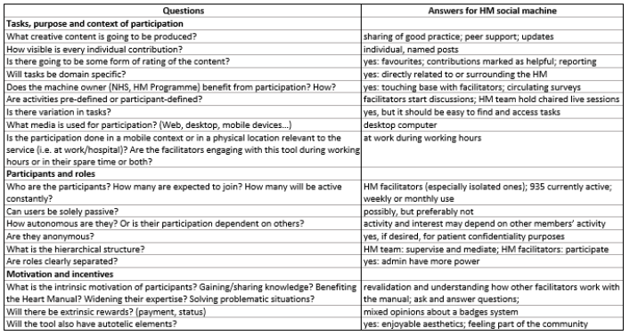

**Fig.1 Questions to guide requirement gathering for a social machine, and answers for the HM social machine**

**Requirements gathering template**

The requirement gathering template is the foundation on which your project stands. It collects what is required and provides a bridge of information between the user and the developer. The user communicates what they require and the developer anticipates them, as well, in order to make sure that everything that is required in the product is accounted for in the requirements gathering.

This requirement gathering template is about business requirements, user requirements and system requirements. It’s a crucial document to complete before any project, especially any IT or software development. It includes all the features and functions of a product and is understandable for all involved, without any ambiguities. Therefore, it helps bring the project to a conclusion that is satisfactory for all parties.

**TASK 1**

Your task is to select a project of your choice and prepare a requirement gathering template for your project. The template is attached in a folder \\colonel\facultyshare\CS\sashraf\spring2024\LABS\LAB1\.

**How to Submit**

* Submit lab work in a single pdf/docx on MS Team.
* Submit the work as per format given in this manual (No other format will be accepted).
* Lab work (Exercises) file name should be saved with your roll number and course code (e.g. 21B-001-SE_SExxx_LWxx.pdf where SExxx is course code and LWxx is Lab number).